Shooty Shooty Arr

A game on the High sees... arr
Kiwi Spy Games (Unless someone thinks of a better company name, this stays)

Table of Contents

Synopsis

Gameplay
– Controls
– Environment
– Characters/ Playable ships(?)
– Camera

Art
- Style
– Ships
– Levels and Level Hazards
– UI

Music and Sound
– Music
– Sound Effects

Menu
– Overview
– Screens

Synopsis

Shooty Shooty Arr is a 2 dimensional indie game being built using Cocos2d-X game framework for C++ development on mobile phones, and Box2D physics engine. The gameplay consists of varying nautical vessels taking turns shooting at each other with true to life trajectory physics in a multitude of landscapes. The player determines where the ship moves in a given movement range, what angle the weapons shoot at, and how much power the weapons have. Players will control one (or perhaps more) ship(s), and attempt to sink the enemies before they are sunk. The challenge comes when the player attempts to shoot; this is due to the angle and power at which the player’s weapon is fired at during differing environmental conditions, or due to the restrictions of the vessel itself. Shooty Shooty Arr plans to have a dynamic and realistic water system which will make for interesting and exciting combat.

Gameplay

The game is set in or on a body of water. The player will be able to control a ship (or ships), or submarine. The game will have a large emphasis on true to life physics, and this will be visible in the water, firing of ships, and the subtle events that occur with these things like wind resistance, buoyancy, rotation and oscillation, lift, drag, and springs. The ships will be made by the player at the start of each level and consist of several objects that the player will have unlocked based on their previous performance throughout the game. Before the player makes their ship and the level starts, the player will be given a brief overview of what the next level will be, and the player can prepare for it.

Players will have a rating out of 3 stars every level. Based on player performance for the previous level, you will have better items unlocked for the next level. If the player has 1 star, they will be limited to only a few weapons compared to a player with 3 stars from the previous level.

Gameplay will consist of players taking turns at attacking each other. Each player's turn
consists of:
– Ship Selection: Select the ship you wish to move this turn
– Move: The player’s selected ship can move a set distance closer to your opponent
OR (Player can either move, or shoot)
– Weapon Select: Select the weapon you wish to use for that turn on the selected ship
– Adjustments: Adjust the angle and fire power of the weapon
– Fire: Fire the weapon
– Opponents turn

Controls

All game controls will be on-screen buttons, or actions during gameplay. Using the mouse (for debugging) or touch screen, press the buttons to perform a specific action indicated by the button. Controls will include:

Move (Left, Right) – Submarine (Up, Down, Left, Right)
Adjust Angle (Up or Down)
Adjust fire power (Up or Down)
Fire
Menu – Restart Level, Exit
Skip Turn

Environment

The game will take place in or on a body of water which may have obstacles, such as underwater mines, floating debris, patches of ice or land, or flying kiwi birds.
Locations:

Locations for levels may include: Calm ocean, Arctic, Ports and bases, volcanic islands, ancient war zones, and swamp or wetlands.

Calm Ocean: A basic level, nothing to impede two ships from shooting at one another.

Arctic: Ice covers much of this area, impeding a ships movement. Ice can be dived under, or broken. Water can also be uneven in this area.

Ports and bases: A special level where you need to siege a heavily fortified, immobile, but volatile enemy.

Volcanic islands: Water is shallow and uneven, with lots of random little pieces of land all about. Pieces of land can be shot at, but not broken by a ship’s hull. Also, at the end of every turn, a volcano has a chance of erupting, showering the players with debris, and lowering visibility to force the players to move closer.

Ancient War Zone: An area with lots of undersea wrecks and mines. Water is fairly shallow.

Swamp: A shallower area which slows down player movement. As the level progresses the player’s available shot power will be lessened. Also Crocodiles.

Note: Some locations can be mixed, such as “Ports and bases” and “Volcanic Island”

Ships

Ships will be built before entering a game. The ships will be made up of several modular simple shapes. You will need to arrange them in a way to make the ship buoyant. Once the frame is done, you need to add weapons and a propelling force.

Pieces:

Hull Pieces: Hull pieces range in weight, value, and material – wood, steel, rubber/plastic, fibre glass, or carbon fibre.
Weapons: Torpedo’s, Rockets, Cannons, Catapults, Machine Guns, or Arrows.
Propulsion: Oars, Sails, Propellers, Rockets, and Fans (think airboat).

Camera
Camera will be free roam during gameplay, allowing players to move left, or right to view the battle area. In free mode, players can select the ship they wish to move or shoot with. Once the ship is selected, the camera becomes fixed on that ship. Once the player has finished selecting the weapon they wish to use and fires, the camera is fixed on the projectile. The camera will pan horizontally with the projectile, but will zoom out as the projectile goes up vertically. When the projectile hits the water, or enemy, the camera will stop following the projectile and reset to a free roam setting.

Art
Style
The style will be dark and gritty mixed with cartoonish elements. The ships themselves will vary in styles depending on scenes. The ships will also have different appearances depending on the material they’re made of.
Ships
Ships will change appearance based on the material they are made from. For example, a steel ship will look completely different from a ship made of wood. Ships made of wood will look similar to old pirate ships, while ships made of steel will look similar to modern ships.
The environment will also change the appearance of the ships. The 3 main ways a level can change a ship are
- Calm Ocean: Which will be what the ship normally looks like
- Arctic: Ships will look damaged and frozen
- Volcanic: Ships will look scorched and have a look of burn damage
Levels
Levels will reflect their environment names in both style, and different levels will contain different objects. Levels will have properties that effect the performance of the ships that are unique to those levels.
Environments:
Normal: contains – birds, clouds, normal/blue water
Arctic: Ice burgs, large chunks of ice in the back ground, water and sky appearance is colder.
Volcanic Island: Rock Debris floating in water, Volcanic island in the background w/ eruption animation, smoke coming out of the volcano, sky has lots of clouds and looks volatile.
Swamp: Area will look very green and murky. Sky will be very much covered by trees, but not completely covered. The water has a green hue to it, and represent plant matter floating at the top.
Ancient Battlefield: This area type has lots of wrecked ships at the bottom, as well as mines randomly under the water.
Port/Base: This is a special area where instead of fighting ships, you go up against an elaborate fortress. Art for this area will consist of a fortified looking base, with lots intimidating factors.
UI:
The UI will be very minimal with visual representation of every important aspect of the ship, and the level.

Music

Music in the game will be public domain naval songs.

Sounds Effects

There will be various sounds in the game. Some sounds being considered:

Menu sounds which will include:

- Different buttons being pressed, or a sound which indicates a transition to another menu.
- Sounds During Gameplay include – a variety of cannon firing sounds (depending on weapon, or weapon strength), a variety of impact sounds, ship sailing/movement sounds, and ambient noises (like birds, waves, or other location based sounds).

Menu

The menu will be easy to navigate and functional. The menu will look like old treasure maps. Menu elements will be:
Play: Takes you to another menu which you have the ability to choose a custom game, or choose one of several challenges.
Instructions: Details about how to play the game.
Options: Gives you the ability to change common aspects of the game.
Credits: Gives credit where credit is due.

Artificial Intelligence
The artificial intelligence used will allow players to face enemies that react how they would expect them to, on their own will. This will be accomplished by creating a ship that accurately strikes the player down, then simplifying that process, which will make the player less susceptible to an attack from the enemy ship. As the levels’ progress, the difficulty, or accuracy, of the enemy’s attack will increase. Each weapon will have its own style of AI, and will have to make the player feel like they are facing an intelligent enemy.
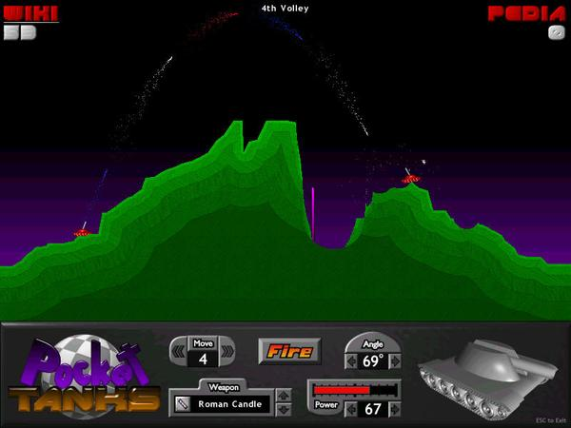
Source: Giant Bomb(http://www.giantbomb.com/pocket-tanks/61-2613/)
Much like Pocket Tanks, there will be enemies facing the player in real time. Creating compelling artificial intelligence will continue to entice players to play long after they have completed all of the levels, as it will always react differently based on the situation.

